Carers Connecting through Learning
A Guide to what is Available

2019/20

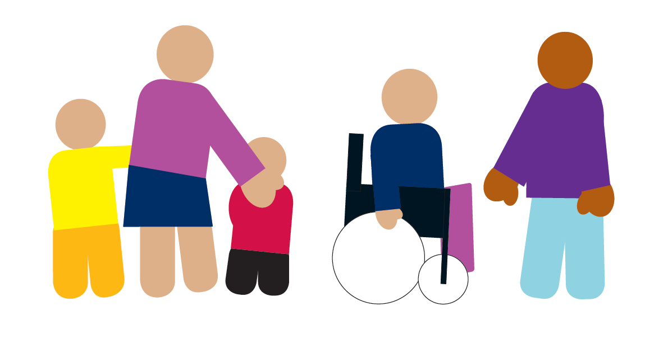
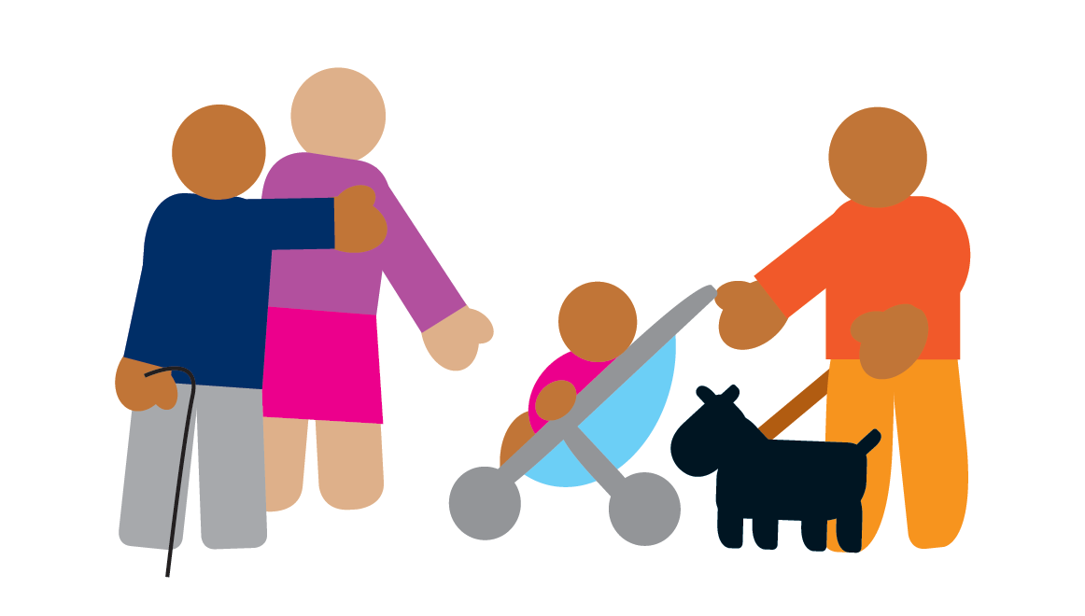

This guide includes information about training organised or paid for by Doncaster Council as well as other resources, training and support opportunities.

Doncaster Council cannot be held responsible for or verify the accuracy or content of the information available from other sources, this is provided to assist.

In this document a Carer is:

- Someone who provides unpaid care for a family member, a friend or another person in need of assistance or support with daily living who could not manage without that support because of a physical or mental illness or impairment or because of a substance misuse issue.

Why is learning/training important?

Offering training is essential to make sure that any carer:
- can work safely
- are good at the job and develop their skills
- develop confidence and a sense of achievement
- can meet other carers and learn from share experiences and knowledge

But I can’t afford it!

Everything in this document is FREE

Contents

Training Courses for Carers…….…………………………………………………………………  How to book courses…………………………………………………. | 4  10
E-Learning (Online Courses)……………………………………….. | 10
Other Support……………………………………………………………..  Making Space Doncaster Carers Service…………………………………………………………………………  Doncaster Partnership for Carers………………………………………………………………………….. | 11  11  11
Appendices………………………………………………………………….  Appendix B – Distance learning Booking form……………..  Terms and Conditions  (for Doncaster Council classroom training courses)……… | 12  12  13

Training for Carers
All training courses are available FREE to carers living in Doncaster.

Alphabetical index of courses. Full course information for each of these courses is available on the Learning Zone.

Course Name | Course Aim | Course Length | Method | Access via:
Adult Obesity | By completing this module you’ll understand what it means to be obese and who’s at risk. You’ll explore why individuals become overweight or obese and the problems that being obese can cause. You’ll also learn what social care practitioners can do to support service users with weight problems. | 35 mins | E learning | Learning Zone
Assistive Technology | This module will introduce you to some key elements of assistive technology and give you an overview of Telecare and Telehealth. You'll also see how appropriate assistive technology can provide solutions for a variety of people requiring support in their own homes. | 35 mins | E learning | Learning Zone
Autism Basic Awareness | This module will cover the key facts about autism, dispel some of the myths about autism, the 'triad of impairment', how sensory information can provoke unusual reactions and guidance on how to interact with people who have autism. |  | E learning | Learning Zone
(Intermediate Knowledge and Skills for Working with) Autism | This module will cover the impact of autism on the family, autism in adolescence, transition to adulthood, autism in adulthood, mental health issues, helping someone get a diagnosis, how to communicate with a person with autism, how to help someone with autism get a job. |  | E-learning | Learning Zone
(Understanding) Autism | To provide an overview of Autistic Spectrum Conditions (ASC) and related conditions to, offering clearer understanding of how it may impact upon an individual’s life and how it may affect their ability to interact with other people and their surroundings. It will also help explain some of the reasons for behaviour that challenges. | 1 day | Classroom | Learning Zone
Autism: Exploring Sensory Issues | To provide an overview of Sensory Integration Difficulties (SID) and related conditions to course participants, offering clearer understanding of how SID may impact upon an individual’s life and their ability to interact with other people and their surroundings. How SID may affect behavioural responses which may be perceived to be challenging. | 1 day | Classroom | Learning Zone
Basic Back Care | This module is designed to raise your awareness of safe manual handling of loads and patients, as well as how to reduce the risk of injury to you or a patient. All delegates on the Moving and Handling Induction MUST complete this module first and bring evidence of completion along to the session. | 45-60mins | E-Learning or Workbook | Learning Zone
Behaviours that Challenge: A Positive and Proactive Approach in Learning Disabilities | To equip workers with the right skills and knowledge relevant to their role and care setting, which will enable them to respond positively to behaviours which may be challenging. | 2 days | Classroom | Learning Zone
Behaviours that Challenge: A Positive and Proactive Approach for Older People | To equip workers with the right skills and knowledge relevant to their role and care setting, which will enable them to respond positively to behaviours which may be challenging in an older peoples’ setting. | 1 day | Classroom | Learning Zone
(All Age) Carers | The module looks at the characteristics that define a carer, including the roles of both young and adult carers. We demonstrate how to identify somebody who might be a carer and how you can help them to find support. | 30 mins | E learning | Learning Zone
Deaf Awareness | This module provides information and guidance on deafness and communication support and it will outline the differing types of deafness and degrees of deafness, the myths surrounding deafness, the various methods of communication used by the deaf and communication support and the use of an interpreter. | 15-20mins | E learning | Learning Zone
Death, Dying & Bereavement | To provide care staff with some information and skills around helping people at end of life, those important to them, other colleagues and themselves to cope with dying, death and bereavement. It meets the requirements of Subjects 5 and 10 of the Department of Health’s End of Life Care Core Skills Education and Training Framework Tier 2. All front line care workers who care/support people at the end of life should receive training at least equivalent to Tier 2 Attendees should have attended the End of Life Care Education Programme – Tier 1 (or equivalent) prior to this. | 1 day | Classroom | Learning Zone
Dementia | This module will cover symptoms and effects of dementia and also the different types and causes. | 25 mins | E learning | Learning Zone
Diabetes Awareness and Support | To enable attendees to understand what diabetes is, how diabetes affects the body and the complications that can occur to know how to support individuals in the management and monitoring of their condition. | ½ day | Classroom | Learning Zone
Dignity & Respect | In this module we'll explore how to promote and sustain dignity and respect for everyone you work with, regardless of their level of understanding. |  | E learning | Learning Zone
Downs Syndrome Awareness | This module looks at the strengths of people with Down's syndrome and the challenges that they face, as well as exposing some common myths. | 15-20mins | E learning | Learning Zone
Dysphagia | To provide delegates with an understanding of Dysphagia and how it occurs, particularly the signs, symptoms and problems associated with the condition and remedies that can help manage the condition. | ½ day | Classroom | Learning Zone
Epilepsy | To enable attendees to gain a greater understanding of Epilepsy and how to support individuals who have this condition. | ½ day | Classroom | Learning Zone
Epilepsy Awareness | The purpose of this module is to improve the learner's understanding of epilepsy, including causes and triggers, types of seizure and methods of treatment. | 45 mins | E-Learning | Learning Zone
(Preventing) Falls | The aim of this module is to give you the knowledge you need to prevent falls and to help keep people safe and independent in their own homes. |  | E-Learning | Learning Zone
Fire Safety Awareness | To provide a basic understanding of fire safety, how to mitigate risk and deal with associated emergency situations. | ½ day | Classroom | Learning Zone
First Aid: Emergency First Aid at Work | To achieve the standard Emergency First Aid at Work Qualification. This will enable the delegate to administer First Aid in the workplace. | 1 day | Classroom | Learning Zone
Fluids and Nutrition: Basic Awareness | To improve understanding of the importance of good nutrition and hydration and how individuals can be supported in a person-centred way to eat and drink well. | ½ day | Classroom | Learning Zone
Food Safety Awareness | This half day course is aimed at domiciliary care workers and residential care workers who do not work in the kitchen or directly prepare meals from scratch. It should be the course of choice for anyone who does not need the Level 2 as an essential qualification for their work. | ½ day | Classroom | Learning Zone
Friends Against Scams | This Module covers the problems with scams, types of scams, spotting a scam and scam victims and reporting a scam. |  | E learning | Learning Zone
Health & Safety in a Health & Social Care Setting | To enable delegates to understand their responsibilities under Health & Safety law and apply that knowledge in order to reduce the risk of injury to themselves or others. | ½ day | Classroom | Learning Zone
Healthier Foods & Specialist Diets, Level 2 | To raise awareness and understanding of healthy eating and catering generally, but also for people with specific nutritional and dietary needs. | 1 day | Classroom | Learning Zone
Healthy Lifestyles | A healthy lifestyle can have many benefits in terms of your physical and mental wellbeing. In this module we will look at the benefits of physical activity and a healthy balanced diet as well as examining ways of maintaining a healthy weight. |  | E learning | Learning Zone
(Essential) Infection, Prevention and Control (IPC) | To provide a basic understanding of the principles of infection, prevention and control and the importance of its application in relation to care settings. |  | Workbook | Learning Zone
Learning Disabilities Basic Awareness (Tier 1) | To improve understanding of what learning disabilities are and their role in supporting people with learning disabilities in a person-centred way. It meets the requirements of the Department of Health’s Learning Disabilities Education Framework Tier 1. | ½ day | Classroom | Learning Zone
Legionella Awareness | This module will help you understand what Legionella is, consider the conditions for its survival in water systems and provide an overview of related legislation. | 30 mins | E learning | Learning Zone
Love Food, Hate Waste | The module explores the key messages espoused by the Love Food, Hate Waste campaign and the key behavioural changes we can make to help reduce the amount of food we waste. | 30 min | E learning | Learning Zone
Manual Handling Awareness (load) | To inform participants of their duties and responsibilities under the regulations, and improve their skill in safe manual handling techniques. | ½ day | Classroom | Doncaster
Handling of Medications | As most medicines have side effects, it is important to understand the seriousness of a person taking medicines unnecessarily or in the wrong way, or taking someone else’s medicine. As a social care practitioner it is vital that you follow guidelines to avoid mistakes. In this module we’ll look at some key areas and what you need to do. | 60 mins | E learning
Medications: Awareness and Administration | To provide an awareness of current legislation requirements and good practice relating to administering, or supporting others to administer medication. | 1 day | Classroom | Learning Zone
Mental Health Awareness | This module will introduce mental health issues, their prevalence and the stigma attached to them. It will also look at the link between employment, homelessness and mental health, cover the different types of mental health illness, the symptoms of psychosis and the links to alcohol and drugs and study the types of treatment available, the effects of stopping medication and discover what therapy based treatments are. | 20 mins | E learning | Learning Zone
Moving & Handling of People (Induction) | To ensure employees/carers have the right skills and knowledge to move and handle people in a safe manner, preventing injury/discomfort for both the client and the employee/carer. Includes: back care and load handling awareness, sitting, standing & walking, bed mobility, hoisting, community specific manoeuvres, small and wheeled equipment, lowering to floor and assisting mobile person off floor. Does not need to be repeated and can be maintained by undertaking the annual update (below). | 1 day | Classroom | Learning Zone
Moving & Handling of People (Update) | For 2019/20 the update focusses on handling larger people and will provide a basic underpinning knowledge of the science of Bariatrics, ensure awareness of local guidelines/procedures for handling the Bariatric person and ensure knowledge of selected people handling techniques. Only available to delegates who have completed the full induction (above) within the last 12 months. | ½ day | Classroom | Learning Zone
Moving & Handling of People (Single-Handed Care) | To provide an awareness of normal movement and its application, ensure knowledge of selected single handed people handling techniques, ensure an understanding of the principles of single handed hoisting, hoist components, an awareness of types and selection of slings, ensure ability to apply principles of single handed hoisting to practical techniques of hoisting and enable staff to identify equipment that could be used for single handed care. Only available to delegates who have an up to date passport by completing the full induction or update (above) within the last 12 months. | 1 day | Classroom | Learning Zone
Nutrition Awareness | This module will give you an introduction to nutrition. It will look at why we eat, the function of food, and explain the 'eatwell plate' and its use. |  | E learning | Learning Zone
(Adult) Obesity | By completing this module you'll understand what it means to be obese and who's at risk. You'll explore why individuals become overweight or obese and the problems that being obese can cause. You'll also learn what social care practitioners can do to support service users with weight problems. | 35 mins | E learning | Learning Zone
Reminiscence | To provide an introduction to reminiscence and the skills and knowledge to enable them to run reminiscence groups and/or carry out one to one reminiscence sessions with their clients. | 1 day | Classroom | Learning Zone
Safeguarding Adults 2016/17 | Welcome to this eLearning course about safeguarding adults at risk for professionals in adult services. |  | E learning | Learning Zone
Safeguarding Adults: Basic Awareness and Reporting Concerns | To develop an effective knowledge of Doncaster’s multi-agency safeguarding adults procedure, the principles, policies, terminologies; and to understand the importance of following appropriate statutory and local procedures. | 1 day | Classroom | Learning Zone
(Caring for) Stroke Survivors | To provide the skills and knowledge to effectively care for and support individuals following a stroke. | 1 day | Classroom | Learning Zone
Strokes | This eLearning module about Strokes will introduce you to the definitions, signs, symptoms and prevention of strokes as well as how to work with individuals who have suffered a stroke. | 35 mins | E learning | Learning Zone

How to book courses
Classroom courses

To check course dates, availability or book on a course please
Ring 01302 736576

Or
Email the following information to awft@doncaster.gov.uk:
  - Your name
  - Email address
  - Your role (e.g. Carer)
  - Whether or not you already have an account with the Learning Zone
Once this information has been input by someone in the workforce development team you will get an email containing a Username and Password.

Please make sure you tell us if you are a Carer when you book.

E-learning – Doncaster Council (DMBC)

Although not for everyone, E-Learning courses can be a faster and easier way of accessing training and information. All courses are FREE OF CHARGE, can be accessed on mobile or fixed devices and candidates will get a printable certificate once completed.

All DMBC online training (and links to the other online training mentioned in this guide) can be found on Doncaster’s Learning Zone: https://doncaster.learningpool.com/login/index.php if this link do not connect copy and paste into your internet browser.
If you’ve not used this before then you need to:

Other Support for Carers

Doncaster Carers Reach Out Service

Doncaster Carers Reach Out Service can help you with: 1:1 support, Information and Peer Support.
1:1 Support - We know that being a carer can be challenging at times, which is why our friendly and compassionate carer support workers are with you every step of the way to make sure you receive the best possible support.
Information - Our job is to make sure your commitment is recognised by those that matter, and that positive steps are taken to enhance, prioritise and protect your wellbeing. We will identify services you, and the person(s) you are caring for, may need and help you get in touch with them.
Peer Support - We believe that being a carer is easier when you have people around you who understand what you are going through. Our peer support groups will bring together a network of carers in your local community who will help pick you up when you're down and celebrate the everyday successes of being a carer.
Address: Gresley House, Ten Pound Walk, Doncaster
Postcode: DN4 5HX
Phone number: 01302 986900
Email: DoncasterCarers@makingspace.co.uk

Doncaster Partnership for Carers

Supporting Carers
The Carers House
2 Regent Terrace, South Parade
Doncaster
DN1 2EE
Tel: 01302 637 566
Email: dpfc@doncastercarers.org.uk
Website: http://www.doncastercarers.org.uk/

Carers UK
The UK's only national membership charity for carers, Carers UK is both a supportive community and a movement for change.
Visit their website
https://www.carersuk.org/home

APPENDIX B
C
Distance Learning: Confirmation of Learner Interest Booking Form

Organisation and Contact Details
Title: |  | Name: |  |  | Phone:
Job Title: |  |  |  |  | Fax:
Organisation Name: |  |  |  |  | Email:
Address:

Postcode:
First Name | Last Name |  | DOB | Course |  |  | NI  Number
TERMS
1. In order to qualify for training, students must be over 19 years of age (born before 01/09/1997), not be in full time education, and have been resident in the EU for the last 3 years. Learners cannot be funded to repeat a course for professional updating.
2. The Assessor must be permitted direct contact with the students for the duration of the course.
3. We reserve the right to cancel or change any aspect of the course.
4. Candidates can only undertake one course at any one time.
5. A charge of up to £125 will be levied for individual learners who fail to complete.
6. Inductions cancelled with less than 48 hours’ notice will incur a cancellation fee of £150
7. I accept that this information will be stored electronically and will be passed to the training provider.
Signature: |  |  |  | Date:
Course Fee: |  | N/A |  | Reference: |  | CAS
To register learners for a distance learning course, please complete the following in Block Capitals and either
- Email: enquiries@castraining.co.uk, or
- Post: CAS Training Ltd, The Bungalow, Quarry Lane, North Anston, Sheffield, South Yorkshire, S25 4DB or FAX: 01909 490279

For further information: Call 01909 518615 or 07764301896 or visit www.castraining.co.uk
Terms and Conditions (for Doncaster Council classroom training courses)

These terms and conditions only apply to Carers as defined below:

- Carer - Someone who provides unpaid care for a family member, a friend or another person in need of assistance or support with daily living who could not manage without that support because of a physical or mental illness or impairment or because of a substance misuse issue.

Anyone else looking to book on to this training should refer to the Terms and Conditions in our main Learning and Development Guide which can be found here: https://doncaster.learningpool.com/pluginfile.php/61955/block_lpfancy/content/IVP_TermsConditions_Apr%2019%20%281%29.doc.
Booking a place on any Doncaster Council Training course will result in automatic agreement to the following terms and conditions for carers (unless stated otherwise):

1 Booking
- Information will be circulated regarding the availability of training opportunities at appropriate intervals. A full copy of the current calendar and is available at
http://www.doncaster.gov.uk/services/adult-social-care/adult-social-care-workforce
- You must book by emailing: awft@doncaster.gov.uk and provide a delegate name for each booking made. Bookings can be amended and substitutes can be sent in place of booked delegates.
- If you are unable to email, or need to discuss any other aspect for an event, you may phone 01302 736576 to book places. You will be asked to provide an email address for booking/event information to be sent to. If this is not possible, we may post information to an address given when booking.
- Confirmation and joining instructions will be issued around 10 working days before the event – usually to the email address provided by the person making the booking. (Please make sure this is the appropriate email address to use).
- You must notify us of any special requirements at least 5 days before the event as requested in the joining instructions.

2 Cancellations
- We will do our utmost not to vary or cancel a course. However, where this is unavoidable, we reserve the right to vary or cancel a course. We accept no liability, if for any reason the course does not take place.

- The Council need to give all training providers and venues sufficient notice of any cancellation based on the terms specified within the contract. If you need to cancel a place on a course and cannot send a substitute, you must notify Rotherham Training Bookings Team by email at least 7 calendar days before the course start date. The team will not accept cancellations by phone (unless there are exceptional circumstances). Where possible, the team will try to find a substitute from any reserve list held to take the cancelled place.

3 Attendance
You are expected to attend training courses as detailed in the joining instructions issued (see point 8.1d above). This means arriving in time and staying for the full course as requested by the trainer. Delegates on courses may be a mix of Council staff and staff working in the IVP sector and it is expected for all delegates to behave in an appropriate and respectful manner towards the trainer, venue staff and each other.

4 Certificates
It is the responsibility of the training provider to provide certificates and wherever possible they will be issued to the delegate on the day by the course trainer. If for whatever reason this is not possible the trainer will take the delegate’s details and ensure a certificate is subsequently posted out to them. The only exception to this is where the course is accredited. In order to achieve the accreditation, it is not possible to issues certificates for these courses on the day. These will be sent on to the Carer following receipt from the accrediting body.

The certificate becomes the property of the delegate, who then is responsible for its safekeeping and for ensuring that if required in future, it is made available for their employer to inspect and/or copy. It may also be required at a future date to confirm date of initial attendance, to support eligibility to attend a ‘refresher’, rather than repeat the full course.

5 Evaluation of the training
In order to maintain the quality of the training provided, and to enable both you and your employer to demonstrate your competence, the Council expects all delegates to complete the relevant evaluation forms, before the course, during and at the end of the course, and 3 to 6 months after the course. This process will be subject to a periodic sample audit to ensure compliance.

Should you have any queries regarding these terms and conditions or about any training courses, please e-mail: awft@doncaster.gov.uk or phone 01302 736576

To book, amend or cancel places, email: awft@doncaster.gov.uk or telephone 01302 736576

